Supply Chain Analysis Project Report
Table of Contents
- Executive Summary
- Business Context & Objectives
- Key Performance Indicators (KPIs)
- Profitability Analysis
  - Profitability Distribution
  - Delay Distribution & Profit vs. Delay Days
- Bottleneck Detection
- Root Cause Analysis
- Time-Based Delay Patterns
- Strategic Recommendations
- Conclusion

Executive Summary
This report presents a comprehensive analysis of the delivery operations of a global e-commerce company managing end-to-end order fulfillment across multiple regions. The analysis covers 172,765 orders spanning January 2015 through January 2018, focusing on identifying root causes of chronic late deliveries, quantifying their financial impact, and establishing a data-driven framework for improvement.
Key Finding | Metric
Overall Late Delivery Rate | 54.71%
On-Time Delivery Rate | 45.29%
Total Orders Analyzed | 1,72,765
Total Profit (profitable orders) | $7.5M
Profile at Risk (delayed orders) | $2.1M

The headline finding is stark: 54.71% of all orders are delivered late, costing the business $2.1M in eroded profitability on delayed orders alone. While total profit from fulfilled orders reached $7.5M, the persistent late-delivery problem represents both a significant financial drain and a major risk to customer experience.
Business Context & Objectives
The company operates a global e-commerce platform selling products across categories including sporting goods, fitness equipment, outdoor gear, footwear, and apparel across multiple international regions.

- Core Business Problem:
Actual shipping times frequently deviate from scheduled delivery windows, creating eroded customer trust, reduced order profitability, and an inability to make reliable commitments to buyers at point of purchase.

- Analytical Objectives
- Understand the current state of delivery performance across all dimensions.
- Quantify the financial impact of delays on order profitability.
- Identify the primary operational bottlenecks driving late deliveries.
- Deliver actionable recommendations to improve on-time delivery and profitability

Key Performance Indicators (KPIs)
The following KPIs were computed directly from the cleaned dataset to establish a performance baseline.
Total Orders | Late Deliveries | Late Delivery % | On-Time Delivery %
1,72,765 | 94,523 | 54.71% | 45.29%
Total Profitable  Orders | Total Loss Due to Delays | 90th Percentile Delay | Avg Order Profit
$7.5 M | $2.1 M | 3 Days | $22.03
- Late Delivery Rate at 54.71% - More than half of all orders arrive late. This is not an edge-case problem- it is the default experience for the majority of customers.
- $2.1M Profit at Risk - Orders that experienced delays collectively generated $2.1M in profit that is under constant pressure from further operational deterioration.
- 90th Percentile Delay = 3 Days - Even the most extreme cases are contained within 3 days of lateness, suggesting the problem is systemic and process-driven rather than catastrophic.
Profitability Analysis
4.1 Profitability Distribution:
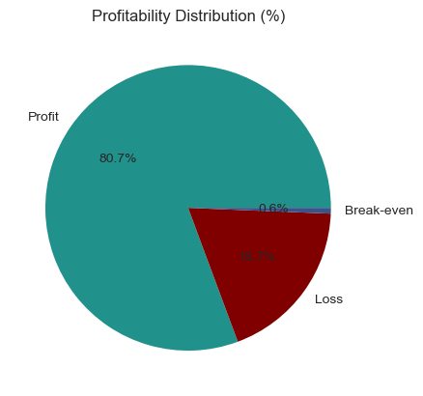
Order-level profitability was classified into three tiers based on Order Profit Per Order. While 80.7% of orders are profitable, the 18.7% loss-making share represents a meaningful drag that is disproportionately concentrated among delayed shipments.
4.2 Delay Distribution & Profit vs. Delay Days
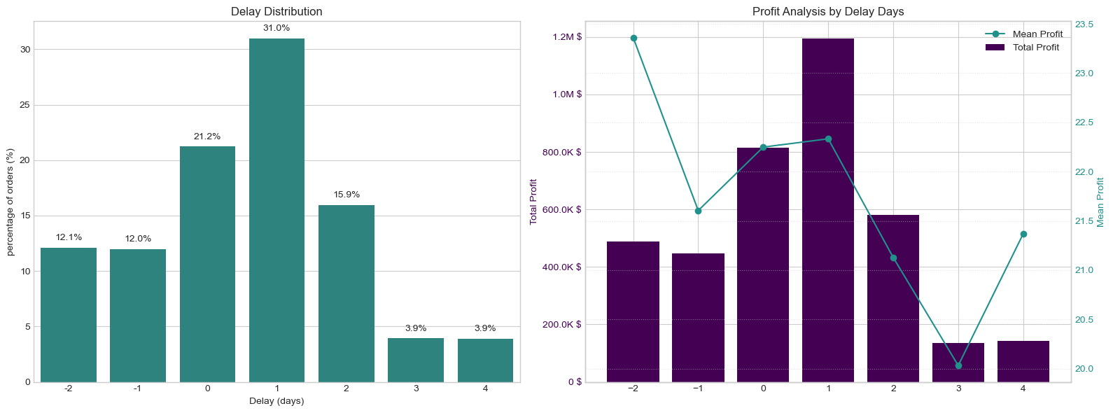
The delay distribution shows that 31.0% of all orders arrive exactly 1 day late the single largest cohort. Combined, orders delayed by 1-4 days account for 54.7% of all order volume, directly mapping to the overall.
Delay Distribution (left) and Profit Analysis by Delay Days (right)
A critical observation: mean profit per order remains stable at approximately $21-$23 across all delay levels. The profitability problem is therefore driven by volume of delayed orders, not by individual order economics making systemic throughput improvement the highest-leverage intervention.
Bottleneck Detection
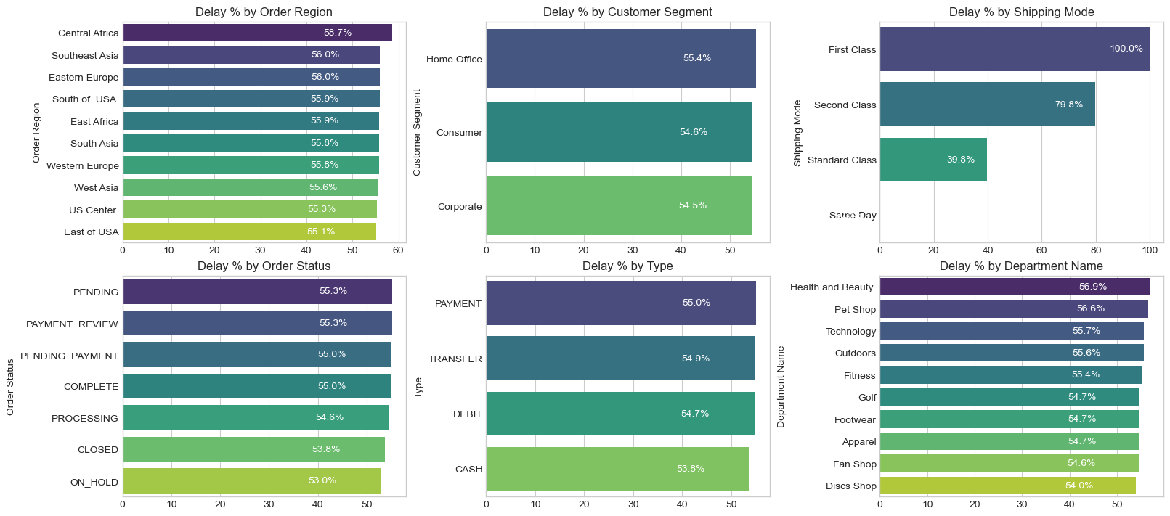
Delay percentage was computed across six key operational dimensions. The charts below reveal where the fulfilment process breaks down most severely.
Delay % across six operational categories – Region, Segment, Shipping Mode, Order Status, Payment Type, Department
- Shipping Mode is the #1 Lever - First Class: 100% delay rate. Second Class: 79.8%. Standard Class: 39.8%. Same Day: 0%. The mode assignment logic is the most impactful single variable to fix.
- Regional Spread is Narrow (55-59%) - Central Africa leads at 58.7% but all regions cluster between 55-59%. This rules out a localized logistics failure and confirms a company-wide systemic issue.
- Customer Segments Nearly Identical (54.5-55.4%) - No segment receives preferential service. All customers - Consumer, Corporate, Home Office experience the same broken delivery promise.
- Health & Beauty (56.9%) and Pet Shop (56.6%) Lead by Department - These departments marginally outpace others in delay rate, warranting an inventory and carrier audit for these product categories.

Root Cause Analysis
Central Africa was selected for deep-dive root cause analysis as the highest-delay region (58.7%). The chart below ranks the top 10 driver factors by delay percentage within this region.
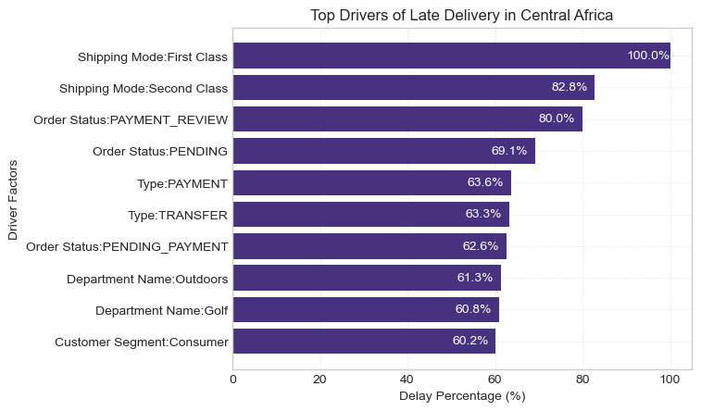

Time-Based Delay Patterns
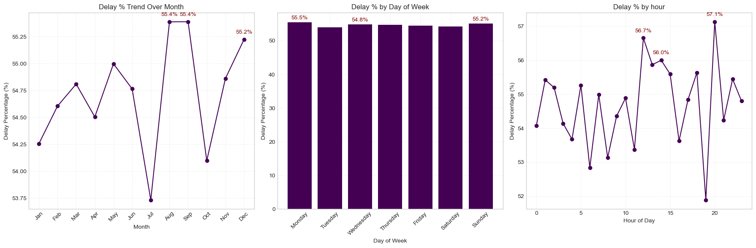
Three temporal dimensions were analyzed: month of year, day of week, and hour of day. While delay rates are relatively stable across all dimensions (53-57%), specific peaks highlight opportunities for targeted capacity planning.

Peak Delay Months –August & September (55.4%) and December (55.2%) –
August and September are the highest months at 55.4%, with December close behind. These reflect mid-year promotions and Q4 holiday surge overwhelming fulfilment capacity. July represents a notable low-point (~53.75%), confirming seasonal variation is plannable.

Day-of-Week Variance is Minimal –
Monday (55.5%) and Sunday (55.2%) are the peak days, but the spread across the week is less than 1 percentage point. Day-of-week is not a meaningful lever for operational intervention.

Intra-Day Peaks - Hour 21 (57.1%), Hour 11 (56.7%), Hour 12 (56.0%) –
Late-evening orders (hour 21) have the highest delay rate at 57.1%, likely reflecting processing cutoff windows. Midday peaks suggest bottlenecks during peak-volume hours.
Strategic Recommendations
Based on the findings across all analytical dimensions, the following prioritized actions are recommended:

1. Immediately Audit First Class & Second-Class Shipping Capacity

First Class shipping has a 100% delay rate and Second Class 79.8%. These modes operate in complete contradiction to their brand promise. Conduct an immediate carrier SLA audit. Until resolved, consider suspending First Class or repricing to reflect actual performance.

2. Deploy the Predictive Alert System

The Random Forest model (74% accuracy, 78% precision on late orders) is ready for production piloting. Integrate it into the order management system to flag high-risk orders at confirmation and trigger proactive customer communication and priority handling queues.
3. Resolve Payment Processing Bottlenecks

Orders in PAYMENT_REVIEW (55.3% overall; 80.0% in Central Africa) and PENDING_PAYMENT (55.0%) have significantly elevated delay rates. Introduce automated escalation for stalled payment reviews exceeding 2 hours.

4. Develop Seasonal Surge Capacity Plans
August, October (55.4%), and December (55.2%) are peak delay months. Build pre-season capacity plans including temporary logistics partnerships, inventory pre-positioning, and adjusted delivery promise windows.

5. Default to Standard Class for Eligible Orders

Standard Class achieves a 39.8% delay rate - far superior to First and Second Class. Re-evaluate shipping mode assignment logic to default eligible orders to Standard Class, particularly in regions and departments with poor premium mode performance.
6. Investigate High-Delay Departments in Africa

Outdoors (61.3%) and Golf (60.8%) in Central Africa show significantly elevated delay rates. Conduct a warehouse-level audit of stock availability, pick-and-pack times, and carrier assignment for these product categories.
Conclusion
This analysis has surfaced a clear and urgent picture: a global e-commerce operation where the majority of orders (54.71%) fail to meet their promised delivery windows, costing $2.1M in at-risk profit and undermining customer trust at scale.

The root causes are identifiable and addressable. Shipping mode misconfiguration (First Class at 100% late, Second Class at 79.8%) is the dominant operational failure. Payment processing friction creates a secondary bottleneck. Seasonal volume spikes are not adequately planned for. And geographic disparities, while present, are secondary to the systemic company-wide pattern.

